Create Active Directory on Windows Server

<http://pc-addicts.com/setup-active-directory-server-2016/>

Azure AD Connect is a bridge solution offered by Azure for an Organisation’s on premise Active Directory or Identity infrastructure and cloud based Azure Active Directory.

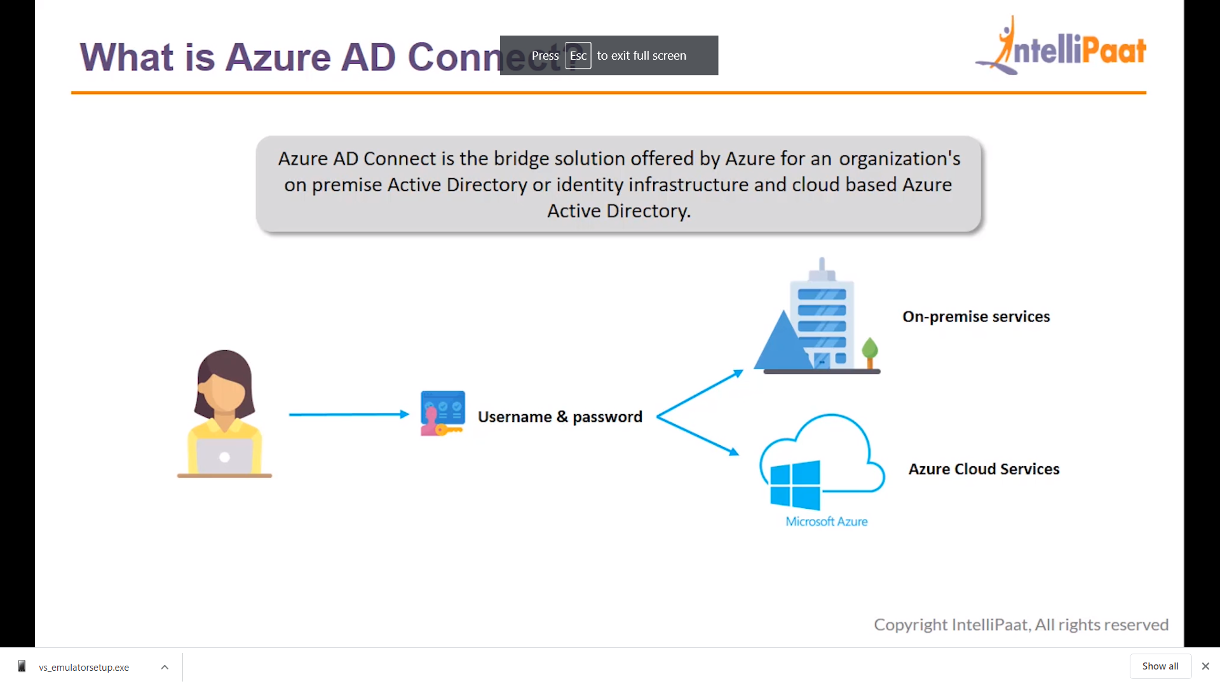

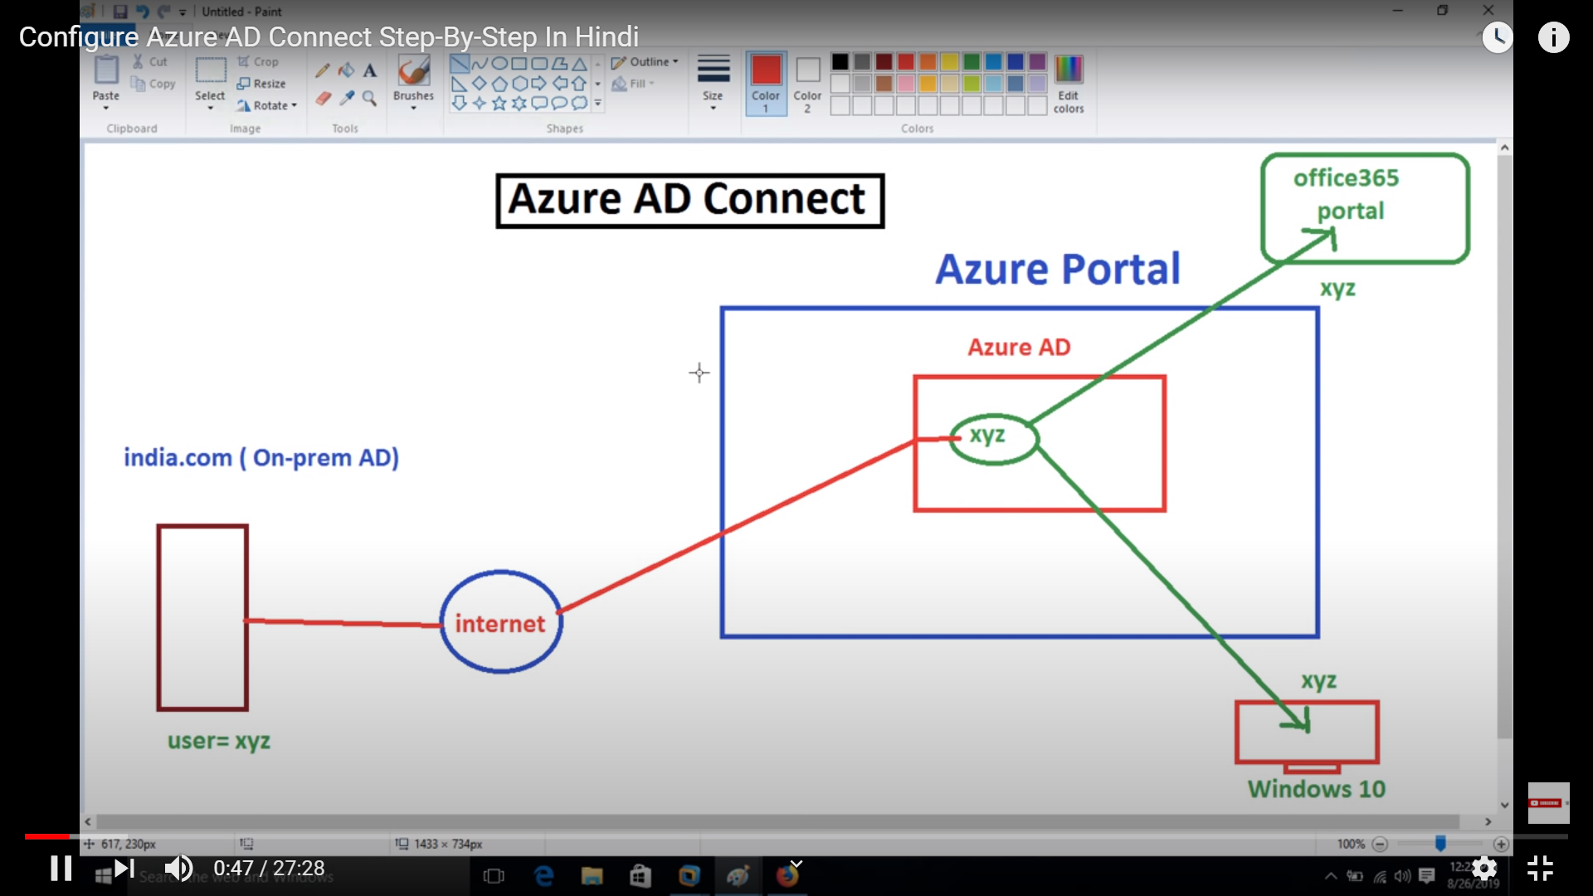

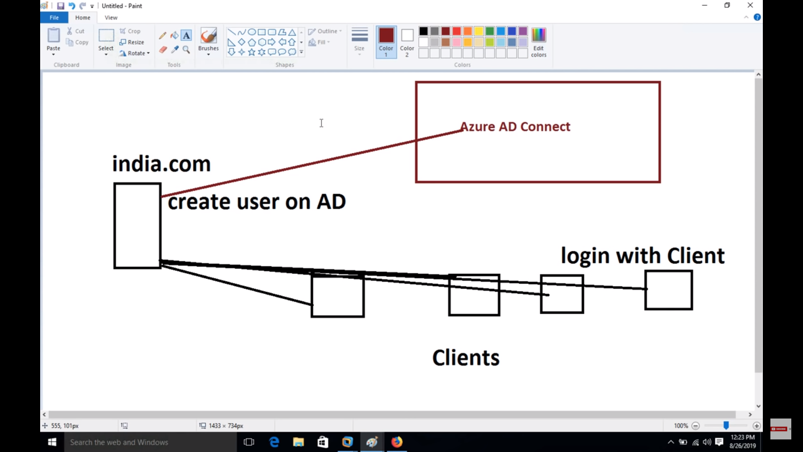

<https://docs.microsoft.com/en-us/azure/active-directory/hybrid/how-to-connect-device-writeback>